TAR UMT Arena AR Navigation App: Node-Based Indoor Navigation System and 2D Map Integration

By

Pui Hock Yang



FACULTY OF COMPUTING AND
INFORMATION TECHNOLOGY

TUNKU ABDUL RAHMAN UNIVERSITY OF MANAGEMENT AND TECHNOLOGY
KUALA LUMPUR

ACADEMIC YEAR
2025/26

TAR UMT Arena AR Navigation App: Node-Based Indoor Navigation System and 2D Map Integration

By

Pui Hock Yang

Supervisor: Tew Yiqi

A project report submitted to the
Faculty of Computing and Information Technology
in partial fulfillment of the requirement for the
Choose an item.

Faculty of Computing and Information Technology
Tunku Abdul Rahman University of Management and Technology
Kuala Lumpur

Copyright by Tunku Abdul Rahman University of Management and Technology.
All rights reserved. No part of this project documentation may be reproduced, stored in a retrieval system, or transmitted in any form or by any means without prior permission of Tunku Abdul Rahman University of Management and Technology.

Declaration
The project submitted herewith is a result of my own efforts in totality and in every aspect of the project works. All information that has been obtained from other sources had been fully acknowledged. I understand that any plagiarism, cheating or collusion or any sorts constitutes a breach of TAR University rules and regulations and would be subjected to disciplinary actions.

__________________________
Pui Hock Yang
Choose an item.
ID: 2401790

Abstract
Navigating large indoor campus buildings can be difficult for students, visitors, and event participants who are unfamiliar with the building layout, room locations, corridors, and floor transitions. General-purpose navigation tools such as Google Maps are effective for outdoor navigation, but they provide limited support for building-specific indoor wayfinding and room-level route guidance. This project focuses on the development of a node-based indoor navigation system and 2D map integration for TAR UMT Arena. The purpose of the project is to provide a clearer and more maintainable indoor navigation foundation by replacing passive PDF-based floor-plan interpretation with structured navigation data and a readable 2D map interface. The project scope covers the design of a node-and-edge indoor route model, the development of a 2D pixel-style map workflow, route visualization, and map-constrained navigation logic. An incremental development approach was adopted, where available floor-plan references were reviewed, building information was collected, early prototypes were tested, and the map and node structure were refined through repeated validation. Graph-based pathfinding techniques such as BFS and Dijkstra were used to support route planning, while map constraints were considered to reduce invalid movement and route drift. The prototype was evaluated based on map readability, correctness of node connections, route validity, maintainability of map data, and suitability for future expansion. The outcome of this project is a practical indoor navigation foundation that can represent rooms, corridors, junctions, and floor transitions in a structured form. Although the current system is still at prototype stage and may require further refinement for full deployment, it provides a scalable base for future integration with AR guidance, Wi-Fi fingerprinting, and stronger indoor positioning methods.

Acknowledgement
This contains acknowledgement to those who have contributed directly or indirectly to the completion of the project. Usually the people to be acknowledged include the project supervisor(s), moderators, family, and those who have given assistance and supports to ensure the success of the project.
Table of Contents
CHAPTER 1: INTRODUCTION
1.1 Project Objectives
1.2 Project Background
1.3 Advantages and Contributions
1.4 Project Plan
1.5 Project Team and Organization
1.6 Chapter Summary and Evaluation
CHAPTER 2: LITERATURE REVIEW
2.1 Literature Review
2.1.1 Indoor Wayfinding Problem Context
2.1.2 Current Indoor Wayfinding Practice in Buildings
2.1.3 Review of Existing Systems and Applications
2.1.4 Review of Relevant Techniques, Methods, and Technologies
A. 2D Indoor Map Representation
B. Node-Based Navigation Structure
C. Map Matching and Path Constraints
D. Drift Reduction Approaches Relevant to This Project
2.1.5 Comparison of Approaches
Comparison of Map Presenting Approaches
Comparison of Indoor Positioning & Map Matching Approaches
2.1.6 Identified Gap and Justification for the Proposed Approach
2.2 Chapter Summary and Evaluation
CHAPTER 3: METHODOLOGY AND REQUIREMENTS ANALYSIS
3.1 Methodology
3.2 Requirements Gathering Technique
3.3 Requirements Analysis
3.4 Functional and Non-Functional Requirements
Functional Requirements
Non-Functional Requirements
3.5 Chapter Summary and Evaluation
CHAPTER 4: DESIGN
4.1 System Design
4.2 UI Design
4.3 Data Design
4.4 Report Design // not sure neede
4.5 Security Design // not sure needed
4.6 Process Design
Route Planning Flow (will be update)
Live Navigation Flow
4.7 Software Architecture Design
Frontend Layered Architecture
Backend Three-Layer Architecture
4.8 Algorithm Design
4.9 Chapter Summary and Evaluation

CHAPTER 1: INTRODUCTION

This chapter introduces the problem context, implemented scope, development direction, and contribution of the indoor navigation modules covered by this report. The discussion focuses on the editable 2D indoor map, the node-and-edge navigation graph, route guidance, Pedestrian Dead Reckoning (PDR), map-based movement constraints, and their integration into the Flutter mobile application for TAR UMT Arena.

1.1 Project Objectives

This report covers the non-Wi-Fi components developed to transform incomplete building references into a functional indoor navigation prototype. The objectives reflect the features implemented in the current codebase rather than proposed future capabilities.

The project objectives are as follows:

- To digitize the currently available Floor 2 building information as a readable 2D pixel-style map with structured room and facility data.
- To construct a machine-readable node-and-edge graph that represents room entrances, corridor junctions, and valid walking connections.
- To implement shortest-path calculation, route visualization, turn instructions, route progress tracking, and arrival handling for selectable destinations.
- To implement a smartphone-based PDR pipeline using motion and heading measurements, then apply route snapping and graph constraints to keep the estimated movement aligned with valid indoor paths.
- To improve maintainability through editable Tiled map data, versioned JSON graph data, an Edge Editor, and exportable navigation documents.
- To integrate these modules into an iOS-first Flutter application with a layered MVVM architecture and verify their behavior through automated testing and partial physical-device validation.

The current prototype deliberately implements Floor 2 rather than claiming complete five-floor coverage. Its canonical graph contains 22 nodes and 24 bidirectional edges, and the room catalogue exposes 14 enabled destinations. The data schema allows future floors and inter-floor connections to be added, but the present graph contains no inter-floor edges. This distinction keeps the project objectives consistent with the implemented and testable scope.

1.2 Project Background

TAR UMT Arena is a large multi-floor campus building used for classes, events, registrations, and exhibitions. Students and first-time visitors may have difficulty locating rooms and facilities when they are unfamiliar with the layout, particularly when they must move between destinations within a limited time.

Existing wayfinding methods, including static signs, verbal directions, and PDF floor plans, provide only passive references. The project team had access to a Floor 2 plan, but not a complete structured representation of all five floors. A PDF also does not directly encode rooms, graph nodes, edge weights, valid walking connections, or route state. These limitations motivated the creation of editable map and graph assets.

The resulting prototype combines a Tiled pixel map, room catalogue, node documents, edge documents, and a canonical map graph. The application uses these assets to search for a destination, compute the shortest connected route, display the path, generate basic turn instructions, track progress, and determine arrival. Therefore, the map and node system now serve as active runtime data rather than only as preparation for future navigation.

Indoor movement estimation introduces a second technical problem. Step length, device orientation, sensor noise, phone rotation, and missed or false steps can accumulate into PDR error. The application processes device motion and heading data, including magnetometer-derived heading when available, and projects the estimated point onto the valid route. It also monitors heading deviation for wrong-way behavior. This is different from magnetic fingerprinting: no magnetic-field fingerprint database is implemented in the current project, and such a database remains outside the present scope.

1.3 Advantages and Contributions

The main contribution of this project is a complete data-to-navigation workflow for the implemented Floor 2 prototype. Building information is no longer represented only as a static document; it is converted into editable visual assets and structured navigation data that can be loaded and validated by the mobile application.

The node-and-edge graph provides explicit identifiers, coordinates, node types, distances, and valid connections. This makes route computation deterministic and allows disconnected or invalid destinations to be detected. The Edge Editor further supports selecting nodes, creating or removing connections, editing distance values, and exporting the resulting JSON document for continued maintenance.

The 2D pixel-style map provides a readable user-facing layer while remaining separate from the graph and room catalogue. This separation allows visual details, room metadata, and routing logic to be revised without treating a PDF image as the navigation database. The runtime can also load a verified map bundle and fall back to bundled resources when a previously verified remote bundle is unavailable.

The navigation contribution extends beyond displaying a map. The implemented application supports destination selection, weighted shortest-path calculation, route rendering, left-right-straight instructions, route simulation, progress and remaining-distance calculation, arrival handling, and wrong-way indication. These functions demonstrate that the graph is operational within the mobile navigation workflow.

The PDR and map-constraint modules provide a practical method for continuous relative movement estimation without claiming absolute indoor positioning accuracy. Motion and heading samples are processed into movement estimates, and the resulting position is snapped to the planned route. The implementation also includes safeguards for phone rotation, shaking, backward movement, and sensor availability.

The project also contributes an iOS-first Flutter implementation organized through domain, application, infrastructure, and presentation boundaries. This structure separates pure navigation logic from sensors, storage, networking, and widgets, which improves testability and makes later platform or map expansion more manageable.

The principal contributions within this report are:

- An editable Floor 2 pixel map, room catalogue, and canonical node-and-edge graph that form the navigation data foundation.
- A functional route-guidance workflow covering destination selection, shortest-path calculation, visual instructions, progress, arrival, and wrong-way monitoring.
- A motion-and-heading PDR pipeline with route snapping and map constraints for keeping relative movement on valid indoor paths.
- A maintainable Flutter architecture, Edge Editor, export workflow, and automated test suite that support continued improvement of the prototype.

1.4 Project Plan

The project followed an iterative implementation and verification process. The phases below describe the work completed for the modules covered by this report; official academic milestone dates should remain in the approved project schedule rather than being inferred from source-code history.

- Building-data collection and map digitization: Review the available Floor 2 reference, observe the building layout, and create the initial Tiled pixel map and room catalogue.
- Graph construction and editing: Define room and junction nodes, connect valid walking edges, assign distances, create the canonical graph, and provide an Edge Editor with JSON export.
- Route-guidance development: Implement destination selection, weighted shortest-path calculation, route visualization, turn instructions, progress measurement, simulation, and arrival handling.
- PDR and map-constraint development: Process motion and heading samples, detect steps, estimate relative movement, snap estimates to the route, and evaluate wrong-way heading conditions.
- Flutter migration and integration: Rebuild the application as an iOS-first Flutter project using MVVM and injected infrastructure ports while preserving the tested navigation behavior of the earlier Expo prototype.
- Verification and device evaluation: Execute static analysis, unit, widget, integration, parity, and native tests, followed by exploratory physical-iPhone sensor sessions. Formal stationary, controlled-walk, complete-route, lifecycle, wrong-way, and Edge Editor device scenarios remain to be completed and must not be reported as passed.

1.5 Project Team and Organization

This final year project is carried out by a two-person team without an external client organization. The system is divided into modules so that each member's technical contribution can be developed, tested, and documented separately while still integrating into one mobile application.

LLH (Leader Herng) is responsible for the AR-related work and Wi-Fi RSSI positioning module. Those components are outside the technical analysis and implementation scope of this report.

Pui Hock Yang is responsible for the 2D pixel-style map and room data, the node-and-edge graph, shortest-path and route-guidance logic, PDR and map-based movement constraints, wrong-way monitoring, Edge Editor workflow, Flutter navigation integration, and verification of these non-Wi-Fi modules.

This responsibility boundary allows the report to evaluate the map, graph, navigation, and motion-processing contributions using their own source assets and tests. Integration points with the other team member's modules may be acknowledged where necessary, but their internal algorithms are not evaluated here.

1.6 Chapter Summary and Evaluation
This chapter introduced the indoor wayfinding problem at TAR UMT Arena and defined the implemented scope of the report. The current deliverable is a Floor 2 prototype containing an editable pixel map, a structured room catalogue, a 22-node and 24-edge graph, and a Flutter navigation interface. It does not yet represent all five floors or any inter-floor route.

The implemented graph is used for destination selection, shortest-path calculation, route rendering, navigation instructions, simulation, progress tracking, arrival handling, and wrong-way monitoring. The PDR pipeline estimates movement from motion and heading data and uses route snapping and graph constraints to align the estimate with valid paths. Magnetometer heading is already used when available, whereas magnetic fingerprint positioning is not part of the present implementation.

Automated analysis and tests provide strong evidence for the deterministic software behavior, and exploratory physical-iPhone sessions confirm that motion permission, sensor streaming, finite heading updates, bounded batching, and start-stop operation can function on a device. However, the formal controlled-walk, complete-route, lifecycle, route-constraint, wrong-way, orientation, and Edge Editor device-validation matrix remains incomplete. Consequently, this report treats reduced drift and improved user wayfinding as design goals to be evaluated, not as already proven outcomes.

CHAPTER 2: LITERATURE REVIEW

2.1 Literature Review

This chapter reviews the literature related to the problem context of indoor wayfinding and the solution direction adopted in this project. The discussion is limited to the scope of this report, namely the need for a better indoor map representation, a structured node-based route model, and the use of map constraints for route consistency. Technologies outside this scope, such as indoor positioning techniques, Wi-Fi RSSI multilateration, and AR navigation, are excluded because they belong to another project component.

2.1.1 Indoor Wayfinding Problem Context

Indoor wayfinding has been widely recognized as a difficult task in unfamiliar and complex buildings. Ghamari and Sharifi (2021) (https://www.mdpi.com/2254-9625/11/2/42) reviewed the literature on indoor wayfinding and reported that navigation problems in unfamiliar indoor environments can cause frustration, anxiety, irritation, and stress. Their review also shows that wayfinding is not only a technical issue, but also a usability and human-factor issue that affects how confidently users move through complex spaces.

This point is especially relevant to multi-floor academic buildings such as TAR UMT Arena. Large buildings usually require users to interpret corridors, room clusters, staircases, and floor transitions at the same time. Bakogiannis, Gkonos, and Hurni (2019) (https://www.mdpi.com/2414-4088/3/1/22) noted that the importance of effective indoor navigation assistance becomes apparent in unfamiliar and complex environments such as universities and hospitals. This matches the target context of the present project, where first-time visitors and even returning users may still struggle to find classrooms, event spaces, or service locations.

The literature also suggests that indoor maps must do more than simply show building geometry. Fang, Xin, Zhang, Wang, and Zhu (2020) (https://www.mdpi.com/2220-9964/9/2/82) found that indoor maps with highlighted paths improve navigational efficiency and reduce cognitive load compared to maps without path emphasis. Their findings are important because they show that map readability is strongly connected to route presentation, not only to the presence of a floor diagram. In practical terms, users need clear routes and decision support, not only access to a building drawing.

2.1.2 Current Indoor Wayfinding Practice in Buildings

In many real buildings, indoor wayfinding still depends heavily on static floor plans, often exported from PDF documents and placed at visible public spots such as pillars, entrances, lift lobbies, or notice areas. This approach is cheap and easy to deploy, but it is passive and limited. A user must first stop walking, find the posted map, determine their current location manually, interpret the layout, memorize the route, and then continue moving. If the user loses orientation after leaving the posted map, the process must be repeated.

This weakness is particularly serious in the target project context. The building being studied has five floors, but the available reference material does not provide a complete and usable set of floor documents for all levels. In addition, static PDF floor plans are usually designed as architectural references rather than interactive navigation tools. They may contain too much visual detail, weak route emphasis, and no step-by-step support. As a result, the map becomes available in public view, but not necessarily effective in helping users navigate.

The literature helps explain why this happens. Gotlib, Wyszomirski, and Gnat (2020) (https://www.mdpi.com/2220-9964/9/6/407) observed that indoor visualizations often appear either as full 3D presentations or as separate 2D floor maps, and that route presentation across multiple floors remains difficult. They also pointed out that many users are not specialists in architectural drawings, so interpretation itself becomes part of the problem. This supports the argument that static PDF-style floor plans are insufficient as a primary navigation interface for ordinary users.

2.1.3 Review of Existing Systems and Applications

Within the scope of this report, two practical reference points are most relevant: static PDF floor-plan navigation and Google Maps.

Static PDF floor plans remain a common building-level navigation aid. Their main advantage is availability. They can be printed, posted in public places, and distributed quickly. However, they have several weaknesses for indoor route guidance:

- They are passive rather than interactive.
- They do not highlight a personalized route from the current location to the destination.
- They rely on the user to interpret architectural symbols and mentally convert the map into real movement.
- They usually separate each floor into a different sheet or diagram, which makes multi-floor route understanding more difficult.
- They are not structured for direct route computation, update tracking, or route correction.

In other words, static floor plans provide reference information, but they do not provide a complete navigation experience.

Google Maps can be mentioned briefly as a contrasting example. It performs very well in outdoor navigation, where road networks, GPS-based context, and turn-based guidance are mature and widely available. However, its indoor usefulness is much weaker for building-specific routing. Google’s own documentation states that indoor maps are available only in selected locations (Google Help, Indoor Maps Availability (https://support.google.com/product-documentation/answer/1685827?hl=en)). This means that indoor coverage is limited and cannot be assumed for a specific campus building. Moreover, Gotlib et al. (2020) (https://www.mdpi.com/2220-9964/9/6/407) used Google Maps as an example of simplified indoor visualization where floor-based presentation remains separated and limited in representing the building route as a complete structured navigation path. Therefore, Google Maps is useful as an outdoor comparison point, but not as a dependable solution for the current project context.

2.1.4 Review of Relevant Techniques, Methods, and Technologies

The literature relevant to this report points to four main technical directions: 2D indoor map representation, node-based navigation structure, map matching/path constraints, and drift reduction support.

A. 2D Indoor Map Representation

The choice of a 2D map is supported by practical and cartographic arguments. Gotlib et al. (2020) (https://www.mdpi.com/2220-9964/9/6/407) argued that full 3D building data are often unavailable, expensive, or difficult to use effectively in navigation applications. They emphasized that simplified 2D-oriented visualization remains useful, especially when applications do not have access to complete 3D data or when software environments do not support complex 3D processing.

This is directly aligned with the present project. The available building documentation is incomplete, and the project requires a representation that can be built from collected source data, edited easily, and rendered clearly for ordinary users. A 2D pixel-style map fits this requirement because it simplifies the building into readable visual blocks while remaining easier to update than complex 3D models or raw architectural drawings. In this project, the 2D map is not merely a visual output; it is the main human-readable layer that makes the structured route information understandable.

B. Node-Based Navigation Structure

The central design foundation of this project is the node system. The literature strongly supports the use of graph- or cell-based structures for indoor route representation. Sultan Alamri (2018) (https://www.mdpi.com/2220-9964/7/4/133) argued that indoor space should be treated as cellular space, where rooms and other indoor components are represented as cells and connections between them are represented logically. In his discussion, rooms, corridors, stairs, and other parts of the building can be modeled as connected graph elements that support routing and query processing.

This idea is highly relevant to the present project becase indoor route guidance depends on decision points. A user does not simply move inside an empty picture; the user makes choices at entrances, junctions, corridor turns, stairs, and floor transitions. A node system captures these decision points explicitly. Each node can represent a meaningful location or turning point, while each edge can represent a valid path between nodes. This makes the route structure computable, verifiable, and expandable.

The node system is also more suitable than a loose or unstructured map representation. A free-form map may look visually acceptable, but if the internal route logic is not encoded, the system cannot reliably determine which turns are valid, which rooms are connected, or which paths are blocked by walls or floor separation. By contrast, a node-based structure transforms the building into a route-aware model. This is why the node system is not a secondary implementation detail in this project; it is the design foundation that makes indoor navigation logic possible.

C. Map Matching and Path Constraints

Once a route structure exists, it must still respect the physical limits of the building. This is where map matching and path constraints become important. Bataineh, Bahillo, Díez, Onieva, and Bataineh (2016) (https://www.mdpi.com/1424-8220/16/8/1302) explained that indoor map information can be used to refine movement paths because it is unreasonable for a walking trajectory to pass through walls or other obstacles. They described map matching as the process of using map information to align a movement sequence with valid spatial structure.

For this project, the important lesson is conceptual rather than algorithmic. The system should not treat the map as a decorative background. Instead, the map should act as a constraint layer that limits movement to valid indoor paths. The node system supports this by defining the legitimate path network, while the map representation makes that network visible. In this way, the proposed solution joins two layers together: the 2D pixel-style map for readability and the node system for valid route logic.

This also connects directly to the drift issue in the current application. When route updates are not strongly constrained by the map and node structure, the displayed movement can gradually deviate from the intended corridor or room path. By contrast, when the route is constrained by the node graph and valid map segments, the system has a stronger basis for keeping movement aligned with real walkable paths. Therefore, the node system is not only useful for route calculation, but also for drift control within the current implementation.

D. Drift Reduction Approaches Relevant to This Project

The drift issue is an important practical concern because a navigation interface loses usability if the displayed route or user movement appears to slide away from the correct corridor, junction, or destination. Within the scope of this report, two relevant solution directions can be discussed: the currently implemented node-based map-constrained approach and the possible future use of magnetic-field support.

The current approach relies on the 2D map, the node system, and path constraints. Its main strength is that it works directly with the project's owned route data. Because the node system defines valid corridors, decision points, and route links, the system can reduce drift by keeping the route interpretation attached to legitimate map structure. This approach is lightweight, easy to maintain, and fully aligned with the current module scope. However, its limitation is that its correction strength depends on the quality of the node map and the clarity of route constraints. If the route structure is sparse or ambiguous, residual drift may still remain.

The future enhancement approach is magnetic-field-based support. Obeidat and Al-Mistarihi (2022) (https://www.mdpi.com/2079-9292/11/6/864) reviewed magnetic-field-based indoor localization methods and noted that magnetic techniques are attractive because they can be used with smartphones and do not necessarily require heavy external infrastructure. Shao, Luo, Zhao, and Crivello (2018) (https://journals.sagepub.com/doi/10.1177/1550147718803072) also showed that magnetic information can be combined with route constraints and motion models to improve path consistency. The advantage of this direction is that it may provide stronger correction if drift becomes serious in the final application. Its disadvantages are higher implementation complexity, the need for magnetic-map collection or calibration, possible device variation, and additional maintenance burden.

For this reason, the present project treats magnetic support as a planned enhancement rather than a compulsory part of the current solution. The current system already uses the more direct and lower-cost option: a node-based path-constrained design. Magnetic support remains relevant only if final performance evaluation shows that the current level of drift control is insufficient.

2.1.5 Comparison of Approaches

The following comparisons help justify the proposed solution direction.

Comparison of Map Presenting Approaches
Aspect | Static PDF Floor Plans | Interactive 2D Indoor Map | Unstructured/Free-Form Map | Node-Based Navigation Structure
Primary Role | Reference document | User-facing navigation map | Visual representation only | Structured route model
User Interaction | Passive | Interactive | Usually limited | Supports route computation
Route Guidance | None or manual interpretation | Can highlight route clearly | Inconsistent | Explicit route paths and decision points
Readability | Often low to moderate | Higher | Depends on design | High when paired with readable map
Multi-floor Reasoning | Weak | Better if designed properly | Often unclear | Can encode floor transitions explicitly
Update & Maintenance | Inconvenient | Easier | Visually editable; logically weak | Easy to validate and revise logically
Suitability | Low | High | Moderate (display only) | Very High (route foundation)

Comparison of Indoor Positioning & Map Matching Approaches
Technical Approach | Basic Concept | Advantages | Disadvantages
Pure PDR + Rule-based Map Matching | Uses step count, step length, and heading to estimate position, then snaps the point to the nearest corridor/edge. | Simplest implementation; very low computational overhead. | Drift accumulates rapidly; prone to picking the wrong "edge" at intersections or long corridors; errors cascade once the wrong path is chosen.
Kalman Filter (EKF/UKF) | Uses state estimation to smooth position and sensor noise. | Low computational cost; real-time performance; excellent for continuous smoothing. | Weak at handling multi-hypothesis scenarios (e.g., branching paths); EKF relies on local linearization which may fail in complex indoor layouts.
Particle Filter (PF) | Uses multiple weighted "particles" to represent possible positions, eliminating those that violate map constraints. | Handles multiple hypotheses simultaneously; ideal for intersections, turns, and map constraints; perfectly suited for PDR + Map Matching. | Higher computational cost than Kalman; parameter tuning is complex; still relies on IMU quality without external absolute references.
BLE Beacon / Fingerprinting | Deploys Bluetooth hardware to estimate position via RSSI or fingerprinting. | Lower infrastructure cost than some hardware; wide smartphone support. | Requires physical deployment of beacons; RSSI is unstable; high maintenance and calibration costs.
Magnetic Fingerprinting | Matches spatial characteristics of indoor magnetic field distributions. | No additional hardware needed; provides absolute position correction. | Requires extensive "magnetic map" collection; sensitive to environmental changes and metal structures; heavy collection process.
Visual / VIO / SLAM | Uses camera features and Visual Odometry to perform positioning. | Extremely high precision potential; significantly suppresses drift. | High computational overhead; complex development; sensitive to lighting and occlusions; high engineering threshold.

2.1.6 Identified Gap and Justification for the Proposed Approach

The literature and practical examples reveal a clear gap in current indoor wayfinding support for buildings such as TAR UMT Arena. Current solutions at the building level often depend on static floor plans that are visible but passive. Broader platforms such as Google Maps are strong in outdoor navigation but limited for building-specific indoor guidance. At the same time, indoor navigation requires more than simple floor images; it requires a structure that can represent valid paths, route choices, and floor transitions, and it must also control drift well enough to remain believable and useful during navigation.

This gap justifies the proposed approach of this project. The project adopts a node-based 2D indoor navigation approach because it matches the available data conditions, supports route logic explicitly, and remains understandable for ordinary users. The 2D pixel-style map provides the readable visual layer, while the node system provides the route-aware structural layer. Map matching and path constraints further strengthen this approach by ensuring that route interpretation remains tied to valid indoor paths rather than loose geometric sketches. For drift handling, the same node system also serves as the key correction foundation in the current implementation, while magnetic support remains a future option if stronger correction is needed.

Therefore, the literature supports the project’s decision to use a node-based 2D indoor navigation design as a practical and academically justified response to the limitations of current indoor wayfinding practice.

2.2 Chapter Summary and Evaluation

This chapter reviewed the literature related to indoor wayfinding difficulties, current building-level navigation practice, and the methods relevant to the scope of this report. The review showed that indoor navigation problems matter because unfamiliar and complex buildings can produce confusion, stress, and route errors. It also showed that static floor-plan navigation is passive and often ineffective, especially when users must interpret PDF-style building drawings without dynamic route support.

From an evaluation perspective, the literature strongly supports the project’s chosen design direction. A 2D indoor map is justified because simplified cartographic representation remains practical when full 3D resources are unavailable or unnecessary. A node-based navigation structure is justified because indoor route guidance depends on explicit decision points, route connectivity, and floor transitions. Finally, map matching and path constraints are justified because indoor navigation should be tied to valid paths rather than treated as free movement on a loose drawing.

Overall, the chapter identifies a clear gap between current passive indoor wayfinding aids and the needs of users in a complex multi-floor building. This gap justifies the proposed system as a more usable, more structured, and more maintainable node-based 2D indoor navigation approach.

CHAPTER 3: METHODOLOGY AND REQUIREMENTS ANALYSIS

3.1 Methodology

This chapter explains how the project was developed and how its requirements were identified and translated into system specifications. Since the project focuses on the node system and the 2D pixel-style map system, the methodology must support repeated validation, correction, and refinement rather than a one-time implementation process.

This project adopts an incremental development approach with rapid prototype evaluation. This approach is suitable because the project started with incomplete building references and uncertain assumptions about whether each technical step would be sufficient for the final application. Instead of committing fully to one design from the beginning, the project was developed through small validated increments. This allowed the team to test whether the available PDF source was sufficient, whether the current node structure was adequate for the minimum viable product (MVP), whether the 2D map was readable enough, and whether further data collection or improvement was necessary.

The incremental approach is appropriate for this project for three main reasons:

- The available building documentation was incomplete, so the project needed repeated checking against the real environment.
- The navigation modules had to be validated step by step to avoid wasting time building an unsuitable representation.
- The project needed flexibility to stop at a satisfactory MVP or continue refining the map, node data, and drift control if the prototype results were not yet good enough.
The methodology used in this project can be summarized as follows:
Phase | Main Activity | Purpose
Phase 1 | Review available PDF floor-plan material and existing references | Check whether current source material is sufficient for implementation
Phase 2 | Conduct site observation and collect building information | Verify room locations, corridors, turns, and floor transitions against the real environment
Phase 3 | Build the initial node-and-edge structure | Represent the building in a structured navigation model
Phase 4 | Create the 2D pixel-style map prototype | Produce a readable visual map for route display
Phase 5 | Validate the prototype and revise data | Check whether the node system and 2D map are sufficient for MVP use
Phase 6 | Observe route consistency and drift behavior | Determine whether the current implementation is stable enough or needs further enhancement

In practice, the methodology behaves as an iterative decision cycle. If the PDF source is insufficient, additional real-world data must be collected. If the node model is insufficient for the MVP, the structure must be expanded or corrected. If the 2D map is not readable enough, the visual layout must be improved. If the current route behavior remains acceptable, the MVP can be retained; otherwise, refinement continues. This makes the methodology efficient because it reduces unnecessary work and ensures that each stage produces a meaningful improvement.

3.2 Requirements Gathering Technique

The requirements for this project were gathered using realistic techniques based on the actual project context rather than formal enterprise-style requirement processes. Since the project is focused on a specific building and does not involve a large-scale stakeholder management process, the requirements were derived mainly from site observation, document analysis, user feedback polling, and team-based technical discussion.

The main requirement gathering techniques are summarized below:
Technique | How It Was Used | Output to the Project
Observation / Site Inspection | Direct observation of the building to understand corridor flow, room positions, turning points, stairs, and floor transitions. | Identified real navigation pain points and verified physical building structure against digital models.
Document Analysis | Review of existing PDF floor plans and available building references. | Revealed that source documentation was incomplete and insufficient as a direct navigation solution, justifying the need for a custom map.
Social Media Poll | A poll on Xiaohongshu (Little Red Book) gauging user difficulty in locating targets in Arena and the demand for a navigation app. | Provided informal user validation that navigation difficulty exists and a digital aid would be welcomed.
Informal Team Discussion | Review of prototype behavior and practical constraints of the node system and 2D map workflow. | Defined the realistic scope for the current module and solidified the technical path forward.

Among these methods, site observation was the most important because the project deals with indoor route structure. The actual usability problems of the building could not be understood only from static documents. Users must physically move through the building to read posted floor plans, and the posted PDF-based maps are often difficult to understand immediately. This observation strongly influenced the need for a clearer and more direct 2D navigation interface.

The document analysis stage showed another important limitation. The project could not rely solely on the available PDF floor plans because the building contains five floors, while the available source material was incomplete. Therefore, the requirement for a maintainable internal route model emerged directly from the weakness of the original reference documents.

The Xiaohongshu poll provided lightweight user-driven evidence. Although it was not a formal survey study, it was useful as a realistic source of requirement confirmation. The results indicated that many users found it difficult to locate places inside Arena and believed that a navigation application would be useful. This supports the practical need for the project.

Overall, the requirement gathering process was intentionally simple but realistic. It reflects the actual resources, constraints, and evidence available to the project, which is more appropriate than claiming formal interviews or analytics data that were not actually used.

3.3 Requirements Analysis

The purpose of requirements analysis is to translate the collected problem information into clear system responsibilities. Based on the requirement gathering stage, the project identified that the main users are students and visitors who are unfamiliar with the Arena building and need a more direct way to understand indoor routes.

The core problems identified are as follows:

- Users are not familiar with the building layout, especially on first visits.
- Static PDF floor plans posted in public places are not straightforward to understand.
- Users often need to walk toward a posted map first before they can even begin interpreting the route, which already wastes time and effort.
- The building layout is large and multi-floor, so route understanding becomes harder when users must mentally convert the posted map into real movement.
- A loose visual map alone is not enough for route guidance; the system must know where valid turns, junctions, and floor transitions exist.
- The navigation output should remain consistent with real walkable paths and should reduce route drift as much as possible within the current implementation scope.

These problems lead directly to the main system responsibilities. The system must present a map that is easier to read than static PDF floor plans, and it must also encode the building as structured route data rather than as a picture only. This is why the node system is central in the requirements analysis. The node system is responsible for representing decision points such as corridor turns, room access points, and valid path connections. Without this structure, the map would remain only a visual reference and would not support reliable route logic.
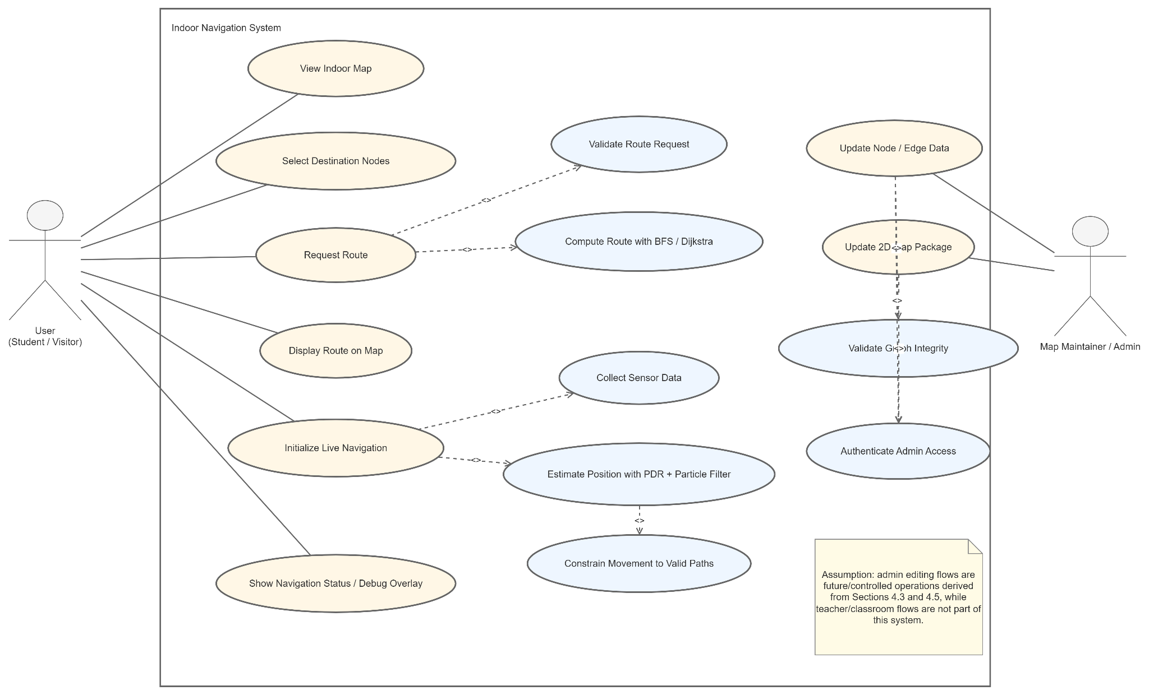
The relationship between user problems and system responses can be summarized as follows:
Identified Problem | Required System Response
User Unfamiliarity: Users are unfamiliar with the building layout. | Provide a readable indoor map and clearer route guidance.
Illegible Sources: Posted PDF floor plans are difficult to interpret. | Replace passive map reading with a more direct 2D navigation view.
Complex Verticality: Multi-floor layouts are confusing to navigate. | Represent floor transitions and route continuity clearly.
Lack of Guidance: Static maps do not provide step-by-step direction. | Use structured route data to support route visualization.
Maintenance Hurdles: Unstructured map data is difficult to update or maintain. | Use a node-and-edge model that can be easily edited and validated.
Navigation Drift: Route displays may drift away from valid walking paths. | Apply node-based path constraints and map matching logic.

3.4 Functional and Non-Functional Requirements

The requirements of the system are divided into functional requirements and non-functional requirements.

Functional Requirements

ID | Requirement Category | Requirement Description
FR1 | Spatial Representation | The system shall represent indoor spaces using structured data for rooms, corridors, junctions, stairs, and floor links.
FR2 | Route Modeling | The system shall create a node-and-edge navigation structure to model valid indoor routes and decision points.
FR3 | Visual Mapping | The system shall display the building through a 2D pixel-style map that is more readable than a static PDF floor plan.
FR4 | Route Visualization | The system shall support route visualization between one point and another based on valid node connections.
FR5 | Vertical Navigation | The system shall support multi-floor route representation through explicit floor transitions.
FR6 | Data Maintenance | The system shall allow the map data and node data to be corrected and updated when building information changes or errors are found.
FR7 | Drift Mitigation | The system shall use valid path constraints to reduce route inconsistency and drift within the current implementation scope.
FR8 | Validation | The system shall support MVP-level prototype evaluation so the team can determine whether the current node map and 2D map are sufficient.

Non-Functional Requirements

ID | Requirement Category | Requirement Description
NFR1 | Usability | The map shall be easy to read for students and visitors with no prior familiarity with the building.
NFR2 | Maintainability | The node structure and map content shall be easy to revise when rooms, links, or visual details need correction.
NFR3 | Accuracy | The node-and-route structure shall correspond closely to the real building layout.
NFR4 | Scalability | The system shall support extension from initial MVP coverage to a wider multi-floor building representation.
NFR5 | Performance | Route display and map response shall be fast enough for practical use.
NFR6 | Reliability | The route model shall avoid invalid movement such as disconnected paths or wall-crossing behavior.
NFR7 | Flexibility | The current design shall allow future enhancements, such as stronger drift correction support, without requiring a complete redesign.

These requirements show again why the node system is a core project component. Many of the functional and non-functional requirements depend on having a structured route model rather than a purely visual map. The 2D map improves usability, but the node system is what enables route validity, maintainability, expansion, and drift control.

3.5 Chapter Summary and Evaluation

This chapter explained the methodology and requirements of the project from an implementation perspective. It showed that an incremental development approach is suitable because the project depends on incomplete source material, repeated prototype checking, and staged decisions about whether the current implementation is sufficient for the MVP. It also explained that the project requirements were gathered realistically through site observation, document analysis, a Xiaohongshu social media poll, and practical team discussion.

The chapter further translated these inputs into system responsibilities and then into formal functional and non-functional requirements. The analysis shows that the most important engineering need is not only to draw a map, but to create a structured node-based route model that can support readable navigation, multi-floor continuity, maintenance, and drift control.

From an evaluation perspective, the chosen methodology is appropriate because it reduces wasted effort. Instead of overbuilding the system too early, the project tests each increment and decides whether more data collection or refinement is necessary. This is especially suitable for an indoor navigation project where the source documents are incomplete and the practicality of the node system and 2D map must be validated continuously. Therefore, the methodology and requirements defined in this chapter provide a realistic foundation for the system design in the next chapter.

CHAPTER 4: DESIGN

4.1 System Design
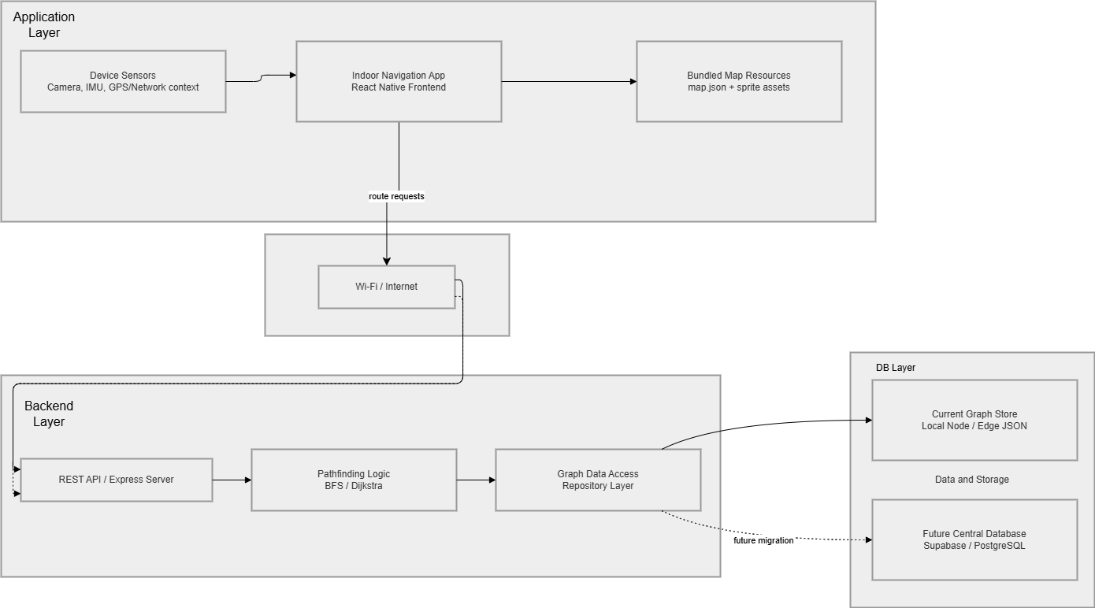
System Design Diagram
The system design of this project describes how the full indoor navigation solution operates from the user device to the backend and data storage. Based on the current implementation, the system contains five major parts: the mobile device, the indoor navigation app, the network connection, the backend node system, and the data storage layer.
At the user side, the system runs on a mobile device. The mobile device provides two important inputs to the application. First, it runs the Indoor Navigation App, which is the software interface used by the student or visitor. Second, it provides device sensor input such as camera access, IMU data, and general device context. These inputs support indoor navigation functions and future extension to more advanced modules.
Within the mobile device, the current app also loads bundled map resources, specifically the local map.json package and sprite assets. This means the frontend can render the indoor map without requiring direct database access. In the current prototype, map resources are therefore obtained from local application assets rather than from the backend or from a cloud database.
When route computation is needed, the mobile app communicates through Wi-Fi / Internet to the backend. This network layer connects the device to the server and carries route requests from the application to the backend API.
At the server side, the backend is implemented as node_system. The backend contains three main internal parts:
- REST API / Express Server, which receives the route request.
- Pathfinding Logic, which executes BFS or Dijkstra to calculate a valid route.
- Graph Data Access / Repository Layer, which reads the stored node-edge graph data.
The current backend reads from the Current Graph Store, which is the local node-edge JSON data used by the project. This is the present implementation and is consistent with the prototype stage of the system.
The diagram also includes a Future Central Database, represented by Supabase . This database is not part of the current live prototype, but it is shown as a future migration target for centralized graph storage. Importantly, the frontend does not connect to this database directly. If the project adopts centralized storage later, the database should remain behind the backend so that all graph access, validation, and route-related logic continue to be controlled by the server.
Therefore, the current end-to-end system flow can be summarized as follows:
- The user interacts with the indoor navigation app on the mobile device.
- The app loads local map resources and receives sensor-related input from the device.
- The app sends route requests through the network to the backend server.
- The backend processes the request through the API, pathfinding logic, and repository layer.
- The backend reads graph data from the current local JSON store and returns the route result to the app.
This system design is appropriate for the present project stage because it keeps the client lightweight, keeps route computation under backend control, and preserves a clear migration path toward a future centralized database if the system is expanded later.

4.2 UI Design

4.3 Data Design
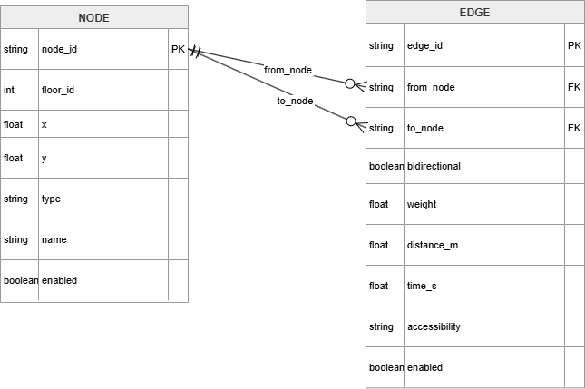
ERD Diagram

The core data design of this project is intentionally small and centered on only two main entities: Node and Edge where the indoor space is represented as a graph.

The Node entity represents meaningful decision points such as corridor turns, junctions, room entrances, stairs, and other navigational landmarks.
The Edge entity represents the valid walkable connection between two nodes.

This design is sufficient for the MVP because route guidance depends primarily on connectivity and direction choices rather than on heavy building-information modeling. The logical relationship is:
1. One node can connect to many edges.
2. One edge must reference exactly two nodes: a `from_node` and a `to_node`.
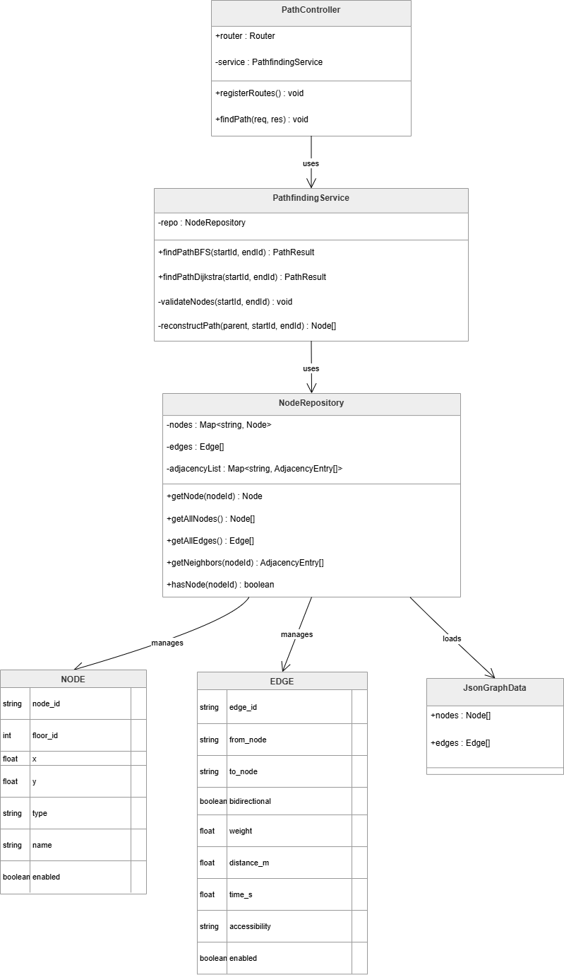Class Diagram

Class | Explanation
PathController | This class is the API entry point of the backend. It receives HTTP requests such as route queries, validates request parameters, selects the requested algorithm, and returns the pathfinding result in a structured JSON response. It acts as the communication boundary between the frontend and backend logic.
PathfindingService | This class contains the core business logic for route computation. Its responsibility is to run the selected pathfinding algorithm, validate whether the requested nodes exist, and reconstruct the final ordered path after the search is completed. It is the main decision-making class in the backend.
NodeRepository | This class is responsible for data access. It reads the node-edge graph data from the stored JSON file, indexes nodes and edges, builds the adjacency list, and exposes helper methods such as getNode, getAllNodes, and getNeighbors. Its role is to isolate storage concerns from the controller and service layers.
Node | This class or entity represents one navigational point in the indoor graph. A node may represent a room entrance, corridor turn, junction, staircase, or other decision point. It stores the semantic and positional data required by the navigation system.
Edge | This class or entity represents a valid walkable connection between two nodes. It defines the structure of the indoor path network by linking one node to another and storing traversal-related information such as directionality, weight, and optional distance.
JsonGraphData | This class represents the raw graph data structure loaded from the JSON source file. It groups the nodes and edges arrays before they are indexed and processed by NodeRepository. In practical terms, it is the initial storage format of the navigation graph.

4.4 Process Design
The system process can be divided into two main flows: the route planning flow and the live navigation flow. The first flow focuses on computing a route between two selected nodes, while the second flow focuses on continuously estimating the user’s position during movement.

Route Planning Flow (will be update)
- The user selects a start node and end node in the application.
- The frontend sends the route request to the backend, or computes it locally depending on the system mode.
- The controller validates the request parameters to ensure that the selected nodes are valid.
- The service layer computes the route using either BFS or Dijkstra.
- The computed route result is returned to the frontend for map rendering.
This flow is responsible for generating the planned path before or during navigation. It ensures that the route is computed in a structured manner and delivered back to the user interface for visualization.

Live Navigation Flow
- The user initializes navigation at a selected node.
- The mobile application starts collecting accelerometer and gyroscope data from the device sensors.
- The sensor service detects step events and turn events from the incoming motion data.
- The navigation engine updates the particle filter based on the detected motion and map constraints.
- The best estimated edge and current position are rendered on the indoor map.
This flow is responsible for tracking the user’s movement after navigation has started. It continuously combines sensor input and map constraints to maintain a realistic estimate of the user’s current indoor location.
Together, these two flows describe how the system first computes a valid route and then supports real-time navigation by updating the user’s estimated position along that route.

4.5 Software Architecture Design
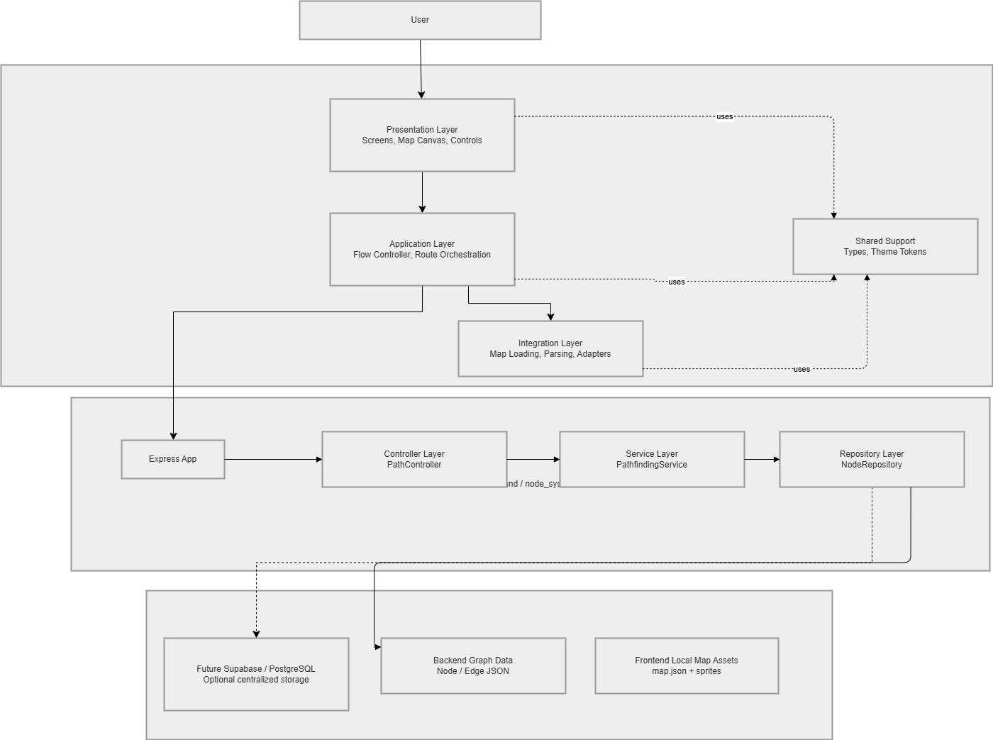
Software Architecture Diagram

Frontend Layered Architecture
The frontend architecture is structured into several logical layers, each with a distinct responsibility.
Frontend Layer | Responsibility | Current Examples
Presentation | User interface rendering and interaction handling | IndoorMapPrototypeScreen, page components, map canvas, floating controls
Application | Flow orchestration and feature coordination | useIndoorMapFlow, route scenario builders
Integration | Data loading and adapter logic | loadPrototypeFloor, mapReference, mapParser
Shared support | Common contracts and visual tokens | shared types, theme tokens
This design improves maintainability because the screen assembly code does not directly own route-construction logic, and route-construction logic does not directly import raw assets. It also improves scalability because a new module, such as AR guidance, can be introduced at the application level as its own feature entry point while still reusing the existing integration and presentation layers.
In practical terms, the frontend architecture behaves as follows:
- The presentation layer renders the map-first interface and captures user interaction.
- The application layer coordinates feature flow and determines which page state and route state should be active.
- The integration layer provides parsed floor data and can later be extended to support backend APIs, Supabase, or AR-related adapters.
- The shared support layer reduces duplication by centralizing common contracts, reusable types, and design tokens.
Overall, this layered frontend architecture provides clearer separation of concerns and makes the mobile application easier to test, extend, and reorganize as the project grows.

Backend Three-Layer Architecture
The backend follows a three-layer architecture consisting of controller, service, and repository responsibilities.
Class | Responsibility
PathController | Accept route requests and return HTTP responses
PathfindingService | Perform BFS and Dijkstra path computation
NodeRepository | Load and expose graph data from storage
This backend structure improves maintainability because each class is responsible for only one major concern. The controller layer handles request and response management, the service layer contains the core route computation logic, and the repository layer manages graph data access. Such separation makes the backend easier to debug, test, and extend.
In practical operation, the backend works in the following sequence:
- The PathController receives the route request from the client.
- The PathfindingService validates the request and executes the selected pathfinding algorithm.
- The NodeRepository supplies the graph nodes, edges, and neighbor relationships needed during computation.
- The computed path is returned to the controller, which formats it as a structured HTTP response.
This architecture is appropriate for indoor navigation because it isolates data access from routing logic and keeps algorithm execution independent from transport-layer concerns. As a result, future improvements such as additional algorithms, weighted edge strategies, or live graph updates can be introduced with limited changes to the rest of the backend.

4.6 Algorithm Design
The system uses two main algorithm groups: route planning algorithms and live map matching algorithms.
For route planning, the backend supports:
Algorithm | How It Works | Purpose
BFS | Starts from the selected start node and explores neighboring nodes level by level until the destination is found. It then reconstructs the discovered route through the parent links. | Used for MVP pathfinding when the main concern is finding a valid route with the fewest graph hops.
Dijkstra | Starts from the selected start node, repeatedly chooses the unvisited node with the smallest current cost, and updates neighboring costs until the destination cost is finalized. | Used when route cost should reflect edge weight or physical distance instead of only hop count.

For live map matching, the mobile app uses:
Technique | How It Works | Purpose
PDR | Estimates user movement from detected steps and heading changes. Each step adds forward movement based on estimated step length and direction. | Provides lightweight continuous motion estimation using smartphone sensors.
Particle Filter | Maintains many possible location hypotheses at the same time. Each particle is moved according to the user motion estimate, scored against heading and path constraints, and weak particles are removed through resampling. | Prevents the system from committing too early to the wrong corridor or branch.
Map constraints | Restrict the estimated motion so that it follows only valid graph edges and indoor paths instead of moving freely through walls or invalid space. | Keeps the final position estimate aligned with the real indoor route network.

4.7 Chapter Summary and Evaluation

This chapter defined the design of the indoor navigation system from the perspectives of system structure, UI, data, process, security, architecture, and algorithms. The design is consistent with the implemented codebase because it treats the backend as a three-layer node service and treats the frontend as a layered mobile navigation client. From an evaluation perspective, the selected design is appropriate for the current project stage. The data model is small but sufficient, the backend architecture is clear, and the class responsibilities are well separated. The ERD with only Node and Edge is also justified because these two entities already capture the essential graph structure required for pathfinding and map matching.

